Programming for Data Science

kester李均扬

Email: [kesterlee@ln.edu.hk](mailto:kesterlee@ln.edu.hk)

Phone: 26167843

# General

meet him at office time at Wong Administration Building

Office Hour:

Monday 2:00 pm - 4:00 pm

Tuesday 2:00 pm - 4:00 pm

Thursday 2:00 pm - 4:00 pm

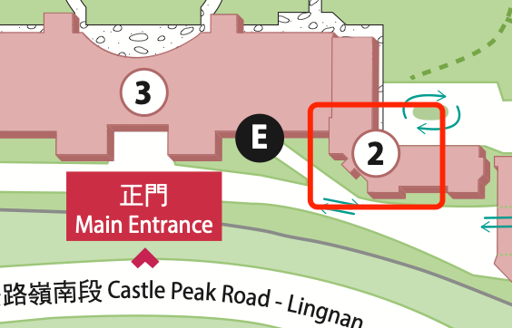

## Assessment

attendance and participation 10%

Assignments 40%

Case Study 20%

Examination 30%

GAI is NOT permitted in assignment, case study and examination in this course.

## Required/Essential Readings

I think better to practice other than read of this course

目录

第1章 General - 1 -

1.1 Assessment - 1 -

1.2 Required/Essential Readings - 1 -

第2章 Week 1 Lecture 1 - 3 -

2.1 Simplified Computer Architecture - 3 -

2.2 CPU Execution Cycle - 3 -

2.3 Programs Stored in Memory - 3 -

2.4 Types of Programming Language - 4 -

2.5 Programming Errors - 4 -

第3章 Week 2 Lecture 2 - 5 -

3.1 What is computation in programming - 5 -

3.2 What is a good program X - 5 -

3.3 What is Python programming language - 5 -

3.4 Relationships among Python Jupyter Pycharm Anaconda - 6 -

3.5 What Is a File Path - 6 -

第4章 Week 3 Lecture 3a,3b - 7 -

4.1 Software Development Process - 7 -

4.2 Python Identifiers - 7 -

4.3 Python Data Types - 7 -

4.4 Python Functions - 8 -

第5章 Week 4 Lecture 4,5,6 - 9 -

5.1 OOP: Object Oriented Programming - 9 -

5.2 string is a list of characters - 9 -

5.3 string operations - 9 -

第6章 Week 5 Lecture 6 - 11 -

6.1 String Representation - 11 -

6.2 String Formatting - 11 -

6.3 File Processing - 12 -

第7章 Week 6 Lecture 7 - 13 -

7.1 Lists vs String - 13 -

7.2 What is Dictionary - 13 -

7.3 Dictionary Operations - 13 -

7.4 Why use dictionary - 13 -

第8章 Week 7 Lecture 8 - 14 -

8.1 Function - 14 -

8.2 Modify Parameters - 14 -

第9章 Week 8 Lecture 9 - 15 -

# Week 1 Lecture 1

## Simplified Computer Architecture

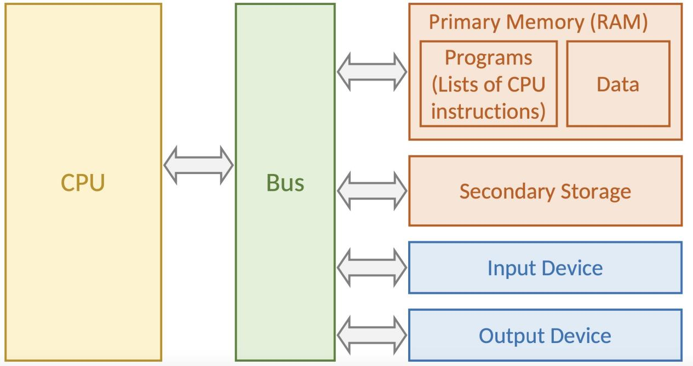

## CPU Execution Cycle

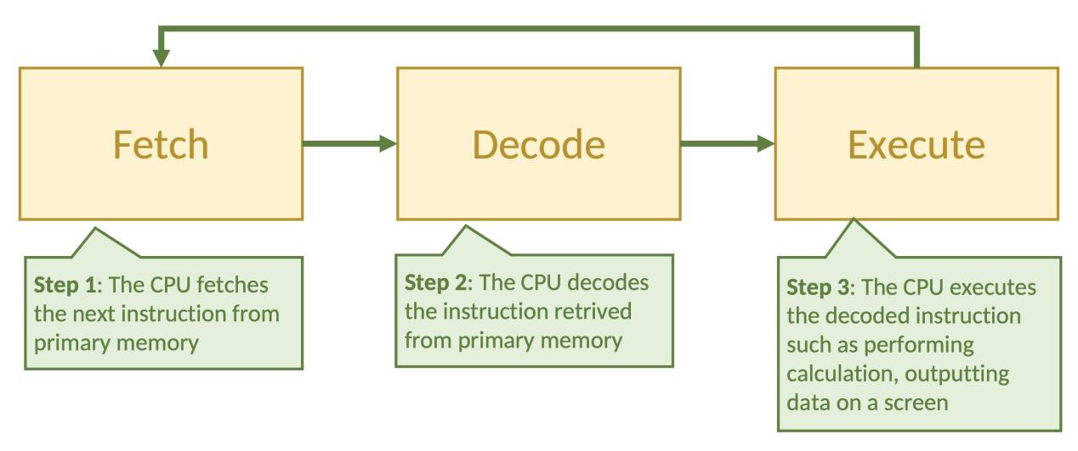

## Programs Stored in Memory

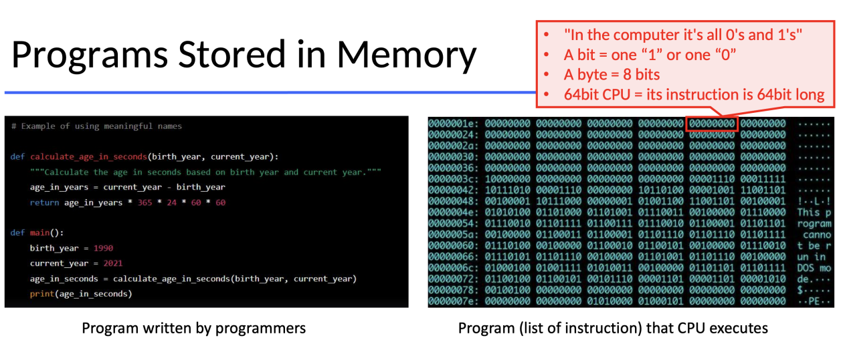

## Types of Programming Language

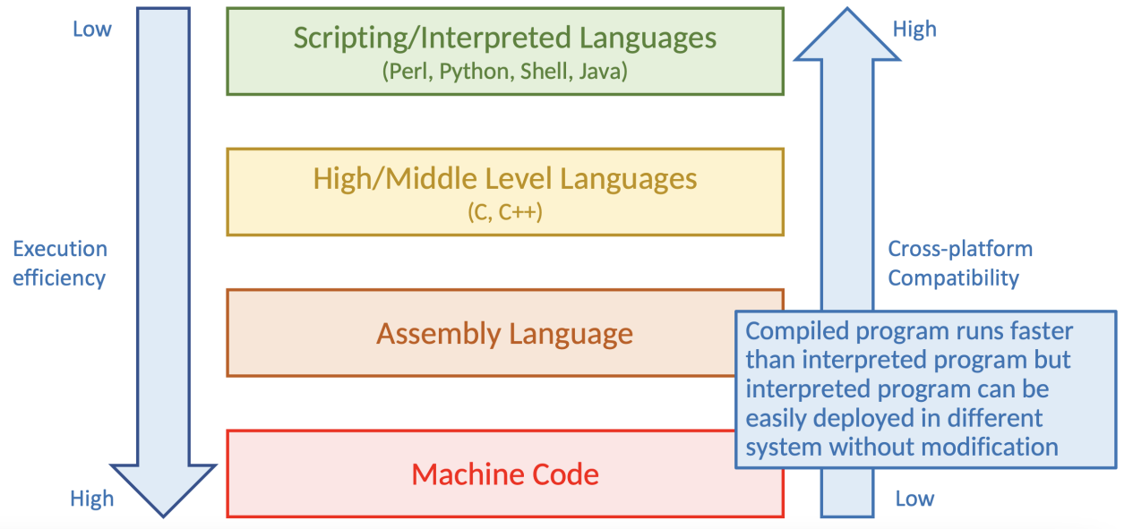

## Programming Errors

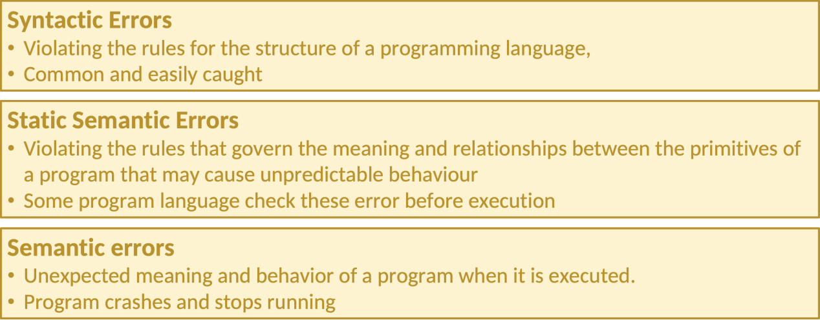

# Week 2 Lecture 2

## What is computation in programming

writing functions to dealing inputs to generate outputs

## What is a good program X

* + Program X is described by step-by-step instructions, i.e. algorithm.
  + Each instruction can be implemented easily.
  + Each instruction is not ambiguous.
  + Each instruction is concise.
  + Program X can be executed quickly on all input instances.
  + Time is money!
  + Program X should be extendable.

## What is Python programming language

* + Python is a programming language which is:
  + Modern, high-level, general-purpose with multiple paradigms (e.g. procedural, object-oriented, and functional programming)
  + Interpreted (No compilation before execution)
  + Dynamically typed (No need to explicitly define the type of variable)
  + Garbage collection (No need to free memory)
  + Latest Major Release: Python 3
  + Previous major release Python 2 is NOT compatible with Python 3 and is scheduled to be discontinued in 2020.

## Relationships among Python Jupyter Pycharm Anaconda

I already know and ask others

## What Is a File Path

* + Absolute path: It specifies the path to navigate and locate a file from the root directory
  + Relative path: It specifies the path to navigate and locate a file related to the current directory
  + Working directory: The directory that the command prompt is pointing to

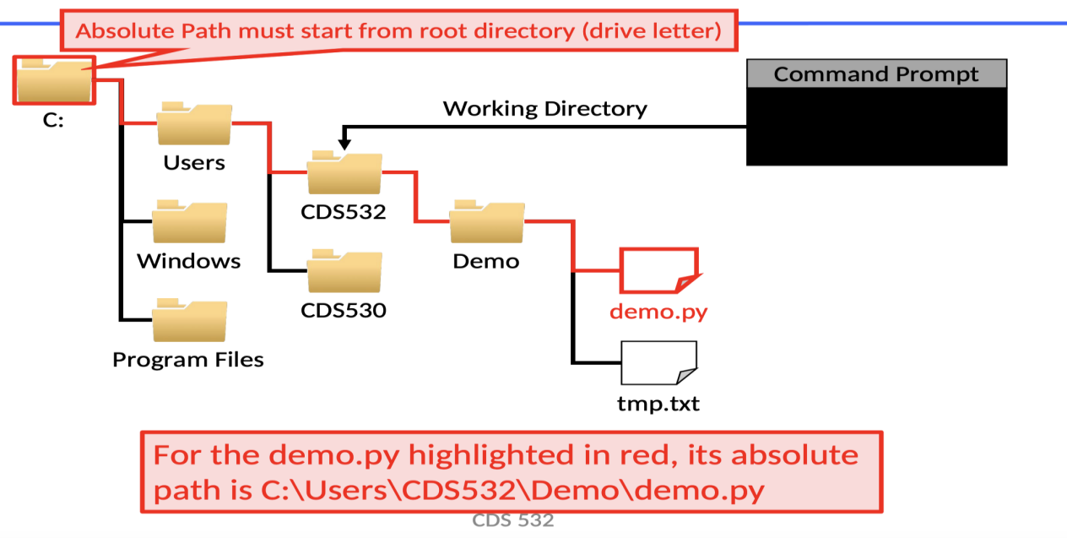

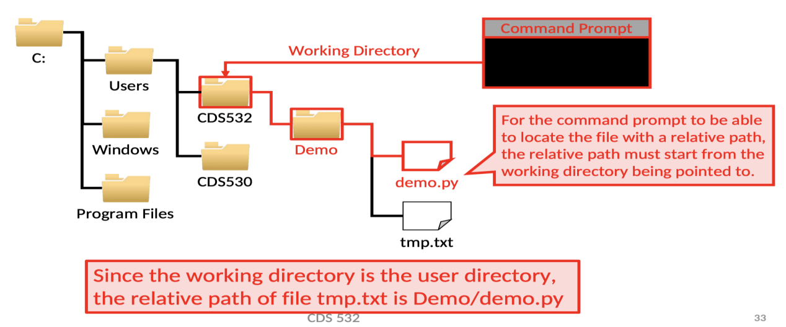

# Week 3 Lecture 3a,3b

## Software Development Process

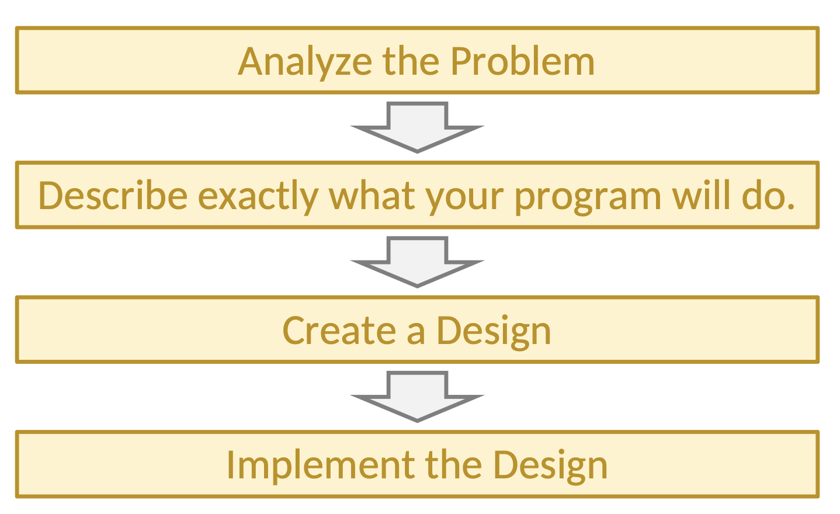

## Python Identifiers

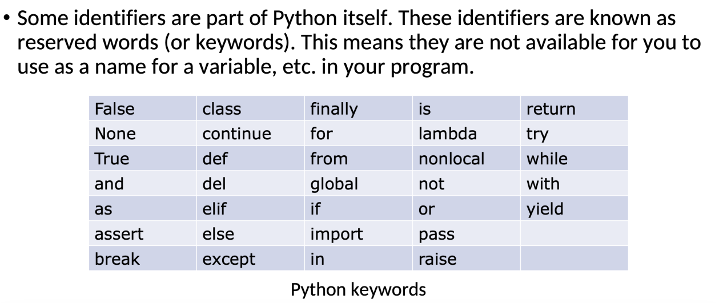

## Python Data Types

Getting the Data Type

print(type(x))

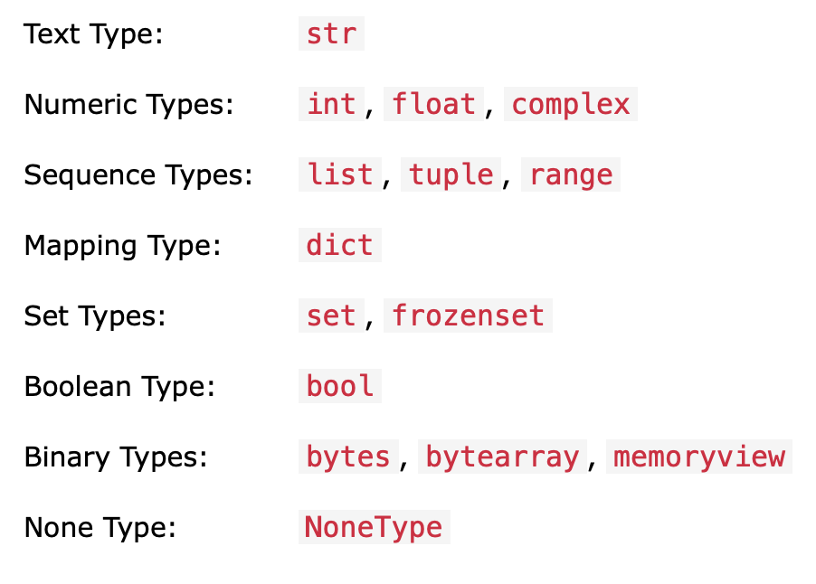

## Python Functions

decision: if: if-else: if-elif-elif-else:

loop: for in: while:

Boolean Operator

()>not>and>or

Numeric Operator

+ - * / // % **

range(start,end,step)

start by default 0

step by default 1

[start,end)

# Week 4 Lecture 4,5,6

## OOP: Object Oriented Programming

variables are classified and managed in object with fields and functions inside

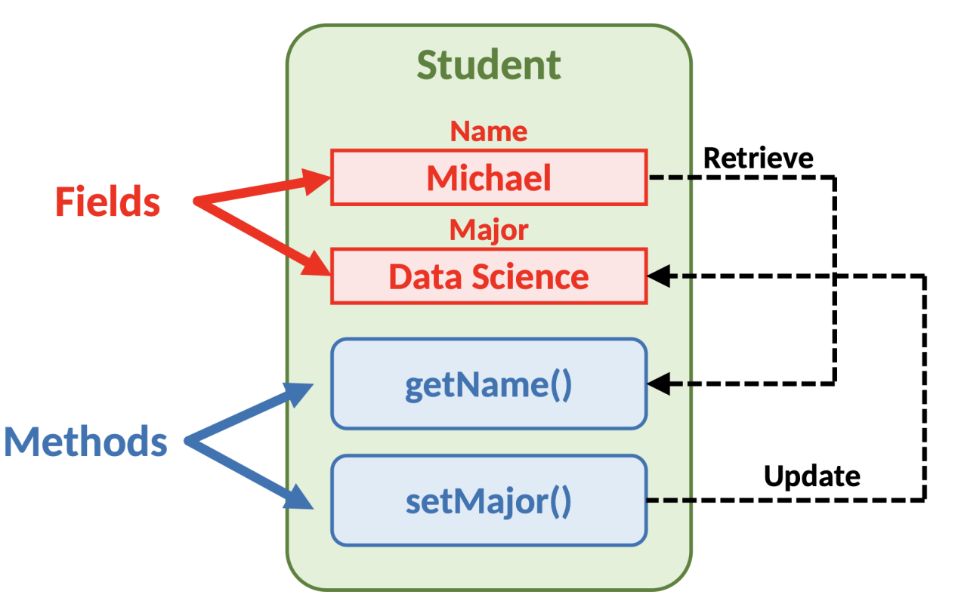

## string is a list of characters

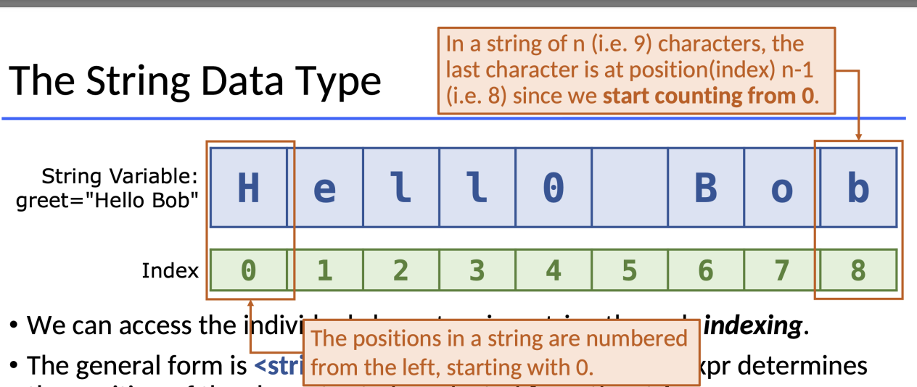

## string operations

slice a list

list[start : end]

start by default 0

step by default n-1

[start,end)

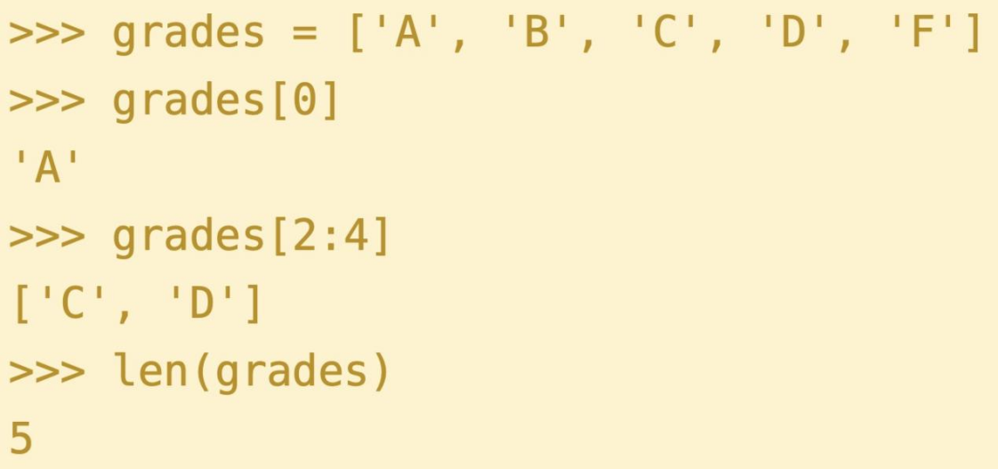

# Week 5 Lecture 6

## String Representation

|  |  |
| --- | --- |
| Method | Meaning |
| numeric_code = ord("A") | returns the ordinal code of a single character |
| character = chr(97) | converts a numeric code to the character |
| float(<expr>) | convert expr to a floating point value |
| int(<expr>) | convert expr to an integer value |
| str(<expr>) | return a string representation of expr |
| eval(<string>) | evaluate string as an expression |
| s.capitalize() | Copy of s with only the first character capitalized |
| s.title() | Copy of s with first character of each word capitalized |
| s.count(sub) | Count the number of occurrences of sub in s |
| s.find(sub) | Find the first position where sub occurs in s |
| s.rfind(sub) | Like find, but returns the right-most position |
| s.split() | Split s into a list of substrings, taking space as delimiter |
| s.join(list) | Concatenate list of strings into one large string using s as separator |
| s.replace (oldsub,newsub) | Replace occurrences of oldsub in s with newsub |
| s.center(width) | Center s in a field of given width |
| s.ljust(width) | Like center, but s is left-justified |
| s.rjust(width) | Like center, but s is right-justified |
| s.upper() | Copy of s in all uppercase letters |
| s.lower() | Copy of s in all lowercase letters |
| s.lstrip() | Copy of s with leading whitespace removed |
| s.rstrip() | Copy of s with trailing whitespace removed |

## String Formatting

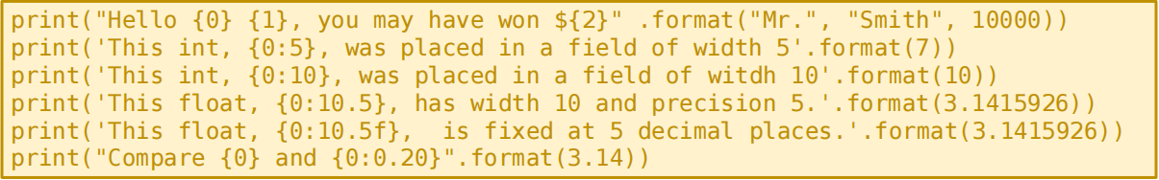

## File Processing

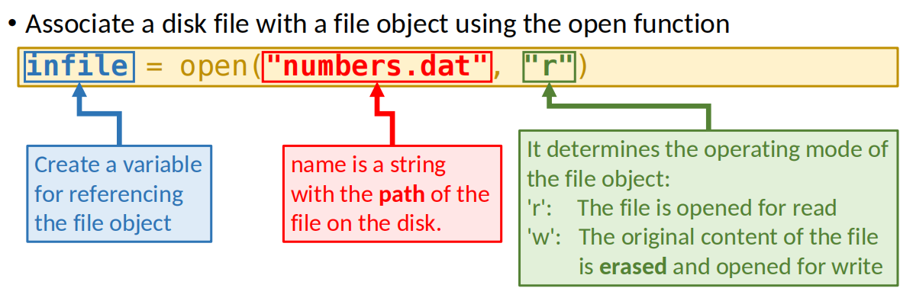

# Week 6 Lecture 7

## Lists vs String

A list is very similar to a string. In fact, string is a special version of list.

Lists are mutable, meaning they can be changed. Strings cannot be

changed.

Operations of String can also be applied to list!

## What is Dictionary

Dictionaries can be created in Python by listing key-value pairs inside of

curly braces

score = {"Peter":"80", "John":"78", "Bill":"90"}

## Dictionary Operations

...

## Why use dictionary

Example Program: Word Frequency

counts[w] = counts[w] + 1

# Week 7 Lecture 8

## Function

Functions can be used to reduce code duplication and make programs more

easily understood and maintained.

## Modify Parameters

Data values are copied and not modified to original ones whereas sited values are changed directly to original ones.

# Week 8 Lecture 9